QUESTION 1
In what location do skin tears most commonly occur?
- Any area of the body.
- Arms and hands.
- Shin or lower leg.
- Head.
Answer(s):

QUESTION 2
Which of these features characterise a skin tear?
- A break in the skin as a result of an injury.
- A traumatic wound that occurred because of friction or shearing and friction.
- The epidermis is torn from the dermis (known as a “partial thickness wound”).
- The epidermis and dermis have torn away from the underlying tissue (known as a “full thickness wound”).
- An injury commonly caused by bumping into furniture or a fall.
Answer(s):

QUESTION 3
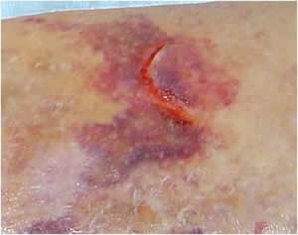
Using the STAR classification system,
which category is this skin tear?

- Category 1a
- Category 1b
- Category 2a
- Category 2b
- Category 3
Answer(s):

QUESTION 4
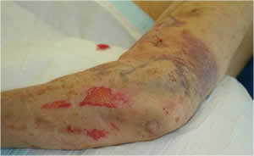
Using the STAR classification system,
which category is this skin tear?

- Category 1a
- Category 1b
- Category 2a
- Category 2b
- Category 3
Answer(s):

QUESTION 5
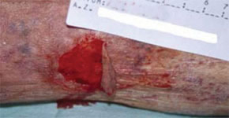
Using the STAR classification system,
which category is this skin tear?

- Category 1a
- Category 1b
- Category 2a
- Category 2b
- Category 3
Answer(s):

QUESTION 6
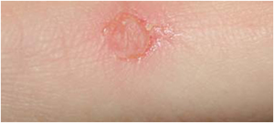
Using the STAR classification system,
which category is this skin tear?

- Category 1a
- Category 1b
- Category 2a
- Category 2b
- Category 3
Answer(s):

QUESTION 7
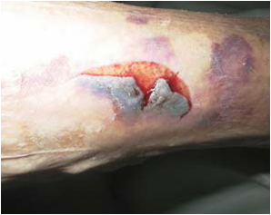
Using the STAR classification system,
which category is this skin tear?

- Category 1a
- Category 1b
- Category 2a
- Category 2b
- Category 3
Answer(s):

QUESTION 8
You should manage skin tears by:
- Controlling the bleeding and cleaning the wound.
- Leaving any separated or lifted skin flaps where they are.
- Assessing tissue loss.
- Leaving the wound open to the air to dry.
- Assessing the client’s general health.
- Applying a dressing.
- Using an adhesive to secure the dressing.
Answer(s):

QUESTION 9
Which of the following strategies help prevent skin tears?
- Using pH neutral products to cleanse and moisturise the skin.
- Gentle handling.
- Covering and padding walking frame supports and wheelchair arms/footrests.
- Ensuring some clients wear limb protectors.
- Ensuring good lighting in bedrooms and living areas.
Answer(s):

