QUESTION 1
Where do diabetic foot ulcers occur?
- On the foot.
- On the ankle bone.
- On the shin.
- Only on the toes.
Answer(s):

QUESTION 2
What are three risk factors for diabetic foot ulcers?
- Duration of diabetes.
- Optimal blood glucose level control.
- Loss of protective sensation.
- Good supply to the arteries.
- Previous ulceration.
Answer(s):

QUESTION 3
Which one of these statements is most accurate about diabetic foot ulcers?
- Have shallow, irregular wound margins.
- Have deep, punched out wounds.
- Are generally shallow or deep ulcers with callous around the wound margin.
Answer(s):

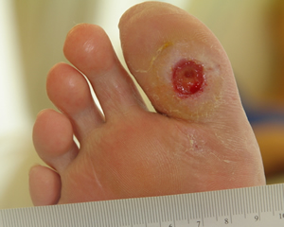
QUESTION 4
This a typical example of a diabetic foot ulcer.
- True.
- False.

Answer(s):

QUESTION 5
Which of the following characteristics require referral to a specialist?
- The Ankle Brachial Pressure Index is less than 0.9 or over 1.2.
- There are signs of infection or inflammation.
- The client would benefit from surgical revascularization.
- The wound can be probed to bone.
- The ulcer, lower leg or foot looks ischaemic.
Answer(s):

QUESTION 6
After a diabetic foot ulcer has been assessed, what are some evidence based treatments you could use to manage the ulcer?
- Ensure offloading of pressure points.
- Use a team approach to care for the client.
- Improve oxygenation.
- Apply a suitable dressing.
- Control risk factors.
Answer(s):

QUESTION 7
How frequently should a client with a diabetic foot ulcer have their skin inspected?
- Daily.
- Every 6 months.
- Annually.
- Only if the client has a problem.
Answer(s):

QUESTION 8
What strategies can you do to prevent or reduce the risk of diabetic foot ulceration?
- Protect the client’s lower legs and feet.
- Examine the feet regularly.
- Encourage exercise.
- Ensuring a well-balanced diet and healthy weight.
- Ensuring optimal control of blood sugar levels.
Answer(s):

