QUESTION 1
What are common types of wounds?
- Traumatic wounds such as blisters, bruises and abrasions.
- Thermal injuries such as burns.
- Wounds inadvertently caused by a clinician, medical treatment or diagnostic procedure such as surgical incision or biopsy.
- Gunshot wounds are the only wounds worth mentioning.
Answer(s):

QUESTION 2
How long would you expect an acute wound to heal?
- Immediately.
- Within 14 days.
- After 6 months.
- Never.
Answer(s):

QUESTION 3
What are the four stages in the wound healing process?
- Vascular response (haemostasis), inflammation, proliferation and maturation.
- Maturation, vascular response, proliferation and inflammation.
- Redness, swelling, heat and pain.
- Pain, redness, heat and swelling.
Answer(s):

QUESTION 4
What are the characteristics of a healthy wound?
- Offensive malodour.
- Ruddy or beefy red tissue in the wound bed.
- Small to moderate amounts of clear (serous) fluid.
- Very painful.
Answer(s):

QUESTION 5
What are some factors that may affect the wound healing process?
- Health of the client.
- Nutrition and hydration.
- Age.
- Medications.
Answer(s):

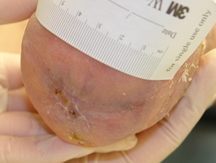
QUESTION 6
Identify the main tissue type in this wound.
- Pink, epithelialising wound.
- Red, granulating wound.
- Green, infected wound.
- Black, necrotic wound.
- Yellow, sloughy wound.

Answer(s):

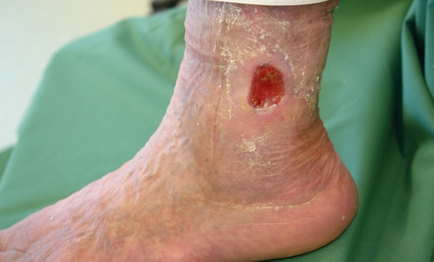
QUESTION 7
Identify the main tissue type in this wound.
- Pink, epithelialising wound.
- Red, granulating wound.
- Green, infected wound.
- Black, necrotic wound.
- Yellow, sloughy wound.

Answer(s):

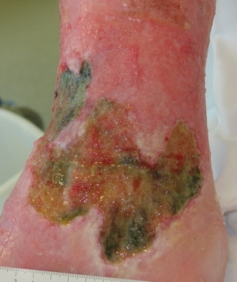
QUESTION 8
Identify the main tissue type in this wound.
- Pink, epithelialising wound.
- Red, granulating wound.
- Green, infected wound.
- Black, necrotic wound.
- Yellow, sloughy wound.

Answer(s):

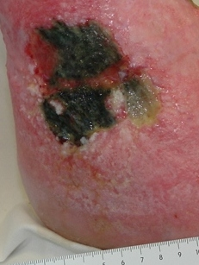
QUESTION 9
Identify the main tissue type in this wound.
- Pink, epithelialising wound.
- Red, granulating wound.
- Green, infected wound.
- Black, necrotic wound.
- Yellow, sloughy wound.

Answer(s):

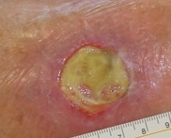
QUESTION 10
Identify the main tissue type in this wound.
- Pink, epithelialising wound.
- Red, granulating wound.
- Green, infected wound.
- Black, necrotic wound.
- Yellow, sloughy wound.
Answer(s):

QUESTION 11
What do typical signs and symptoms of infection include?
- Heat and redness in the skin around the wound or extending more than 2cm beyond the wound margins.
- Swelling around the wound.
- Pain that has changed in intensity.
- Wound tissue bleeds easily when touched or abnormal granulation tissue.
- Offensive odour.
Answer(s):

QUESTION 12
What strategies are involved in wound management?
- Wound cleansing and debridement.
- Providing a moist wound healing environment.
- Pain management.
- Documentation.
Answer(s):

QUESTION 13
What are some strategies that can be employed to prevent a wound from occurring?
- Treatment of underlying medical conditions such as diabetes.
- Cessation of smoking.
- Increasing alcohol intake.
- Not applying a dressing if an injury to the skin occurs because it heals quicker if left to dry out.
Answer(s):

