QUESTION 1
Why is the skin so important for us?
- It protects our body.
- It controls our temperature.
- It allows us to feel pain.
- It helps us metabolise Vitamin D.
- It produces sweat and oils.
Answer(s):

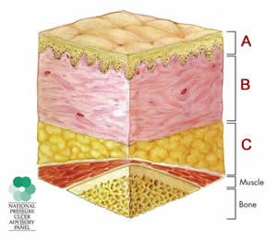
QUESTION 2
What are the correct labels for this diagram?
- A = Epidermis B = Adipose Tissue C = Dermis
- A = Adipose Tissue B = Dermis C = Epidermis
- A = Dermis B = Epidermis C = Adipose Tissue
- A = Epidermis B = Dermis C = Adipose Tissue
Answer(s):

QUESTION 3
Which of these statements is most accurate?
- The likelihood of having a wound increases with age.
- The number of wounds decreases with age.
- Wounds occur in all age groups regardless of age.
Answer(s):

QUESTION 4
Which of these skin changes are typical of people as they age?
- The skin becomes more sensitive.
- The skin becomes drier.
- The skin becomes thicker and more elastic.
- The skin is more likely to become infected.
- It is easier for the skin to control temperature.
- The skin bruises more easily.
- The density of hair on the scalp decreases and hair grows more slowly.
Answer(s):
QUESTION 5
When you are ready to consult with a client, what should you do to prepare the environment?
- Make sure the room temperature is comfortable and that the room lighting is bright enough for your examination.
- Start singing or humming a happy song (e.g. "Love is in the air, everywhere I look around...").
- Turn on the TV so the client can watch a popular TV program (e.g. "The Oprah Winfrey Show").
- Display posters on the wall that show photos of typical wounds.
Answer(s):
QUESTION 6
You are consulting with a client who you notice has yellow fingers. What do you say to gather information about this problem?
- Oh dear, this doesn't look good.
- Why are your fingers so yellow?
- Please tell me if you smoke cigarettes.
- What's your date and place of birth?
Answer(s):
QUESTION 7
When you observe a client's skin, which one of these statements is most likely true?
- Cold feet may indicate a circulation problem.
- Smooth skin means it is very dry.
- Blue skin may be due to a liver problem.
Answer(s):

