QUESTION 1
What is the cause of a venous leg ulcer?
- Low blood pressure in the veins in the lower limb.
- High blood pressure in the veins in the lower limb.
- Blocked arteries.
- History of heart attacks.
Answer(s):

QUESTION 2
What are three risk factors for venous leg ulcers?
- Obesity.
- Varicose veins.
- Younger age.
- Family history.
Answer(s):

QUESTION 3
Which one of these statements is most accurate about venous leg ulcers?
- Have well defined, regular wound margins.
- Are generally dry, with little or no leakage.
- Are generally described as having a ruddy or beefy red, granular appearance with irregular wound margins.
- Are not associated with swelling.
Answer(s):

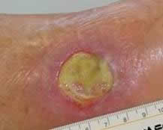
QUESTION 4
Is this a typical example of a venous leg ulcer?
- True.
- False.

Answer(s):

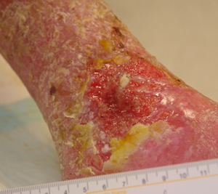
QUESTION 5
Is this a typical example of a venous leg ulcer?
- True.
- False.

Answer(s):

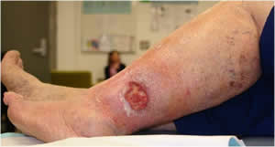
QUESTION 6
Is this a typical example of a venous leg ulcer?
- True.
- False.

Answer(s):

QUESTION 7
Venous leg ulcers are characterised by:
- Pain at night when the client’s legs are elevated.
- Pain when walking.
- No pain.
- Pain that is relieved by elevating the legs above heart level.
Answer(s):

QUESTION 8
After a leg ulcer has been assessed and diagnosed as a venous leg ulcer, what is an evidence based treatment you could use to manage the ulcer?
- Apply a dressing and secure with a crepe bandage.
- Leave the wound open to dry in the sun.
- Apply an antimicrobial dressing.
- Apply a compression bandage or stocking.
- Change the compression bandaging twice a day.
Answer(s):

QUESTION 9
What should you consider before applying a compression bandage?
- Skin condition.
- Shape of the lower leg.
- Lack of sensation.
- Other health conditions such as heart disease.
Answer(s):

QUESTION 10
What can you do to prevent venous leg ulcers?
- Provide compression bandages or compression stockings.
- Ensure clients elevate their legs.
- Encourage clients to lift weights.
- Ensure clients do ankle and calf muscle exercises.
- Encourage clients to cross their legs when sitting.
- Check the lower legs daily for signs of swelling or skin breakdown.
- Ensure clients stand or sit in the same position for a long time.
Answer(s):

QUESTION 11
Graduated compression stockings should be replaced at least every:
- 6 months.
- 9 months.
- 12 months.
- 24 months.
Answer(s):

QUESTION 12
What is the correct height for leg elevation?
- At waist height.
- Higher than the heart.
- Flat in bed.
- Below waist height.
Answer(s):

