QUESTION 1
What are the causes of pressure injuries?
- Pressure or pressure in combination with shear and/or friction.
- Pressure injuries only occur if pressure is applied for more than four hours.
- Dry skin.
- Only clients who are bed-bound get pressure injuries.
Answer(s):

QUESTION 2
Risk factors for pressure injuries occurring include:
- Being physically immobile and unable to independently change position.
- Decreased sensation (i.e. being unable to feel).
- The presence of constant moisture.
Answer(s):

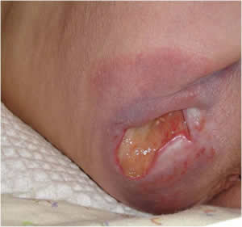
QUESTION 3
What stage would you classify this pressure injury as?
- Stage 1.
- Stage 2.
- Stage 3.
- Stage 4.
- Suspected deep tissue injury.
- Unstageable.

Answer(s):

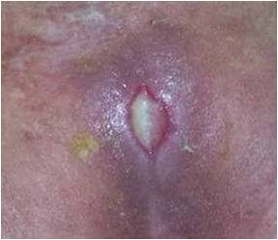
QUESTION 4
What stage would you classify this pressure injury as?
- Stage 1.
- Stage 2.
- Stage 3.
- Stage 4.
- Suspected deep tissue injury.
- Unstageable.

Answer(s):

QUESTION 5
What are some evidence based strategies you could use to manage a pressure injury located on the buttocks?
- Ensure pressure relieving surfaces and a regular repositioning schedule are in place 24 hours/day.
- Keep the head of the bed elevated and the client sitting up.
- Avoid positioning the client on the pressure injury.
- Give the area a rub every 2 hours to improve the circulation.
- Assess, classify and document the stage of the injury.
- Provide nutritional supplements if the client is undernourished.
Answer(s):

QUESTION 6
What strategies can be used to prevent pressure injuries?
- Have a regular turning schedule.
- Use soap-free cleansers on the skin to avoid dryness.
- Ensure optimal nutrition and hydration.
- Ensure pressure offloading equipment is in place.
Answer(s):

QUESTION 7
To prevent pressure injuries you should not:
- Give the client a foam ring or donut to sit on.
- Check the client’s skin regularly.
- Ensure limited exposure to excessive moisture.
- Use non-soap products.
Answer(s):

